SC4000i E-O Genset Explosive View

E-01 机芯组件………………………2～3 E-02覆盖件组件………………………4~6
Machine core components Overlay component
E-03 机架组件……………………7～8 E-04底板组件……………………… ..9～10

Frame assembly Base plate assembly

E-01 机芯组件Machine core components
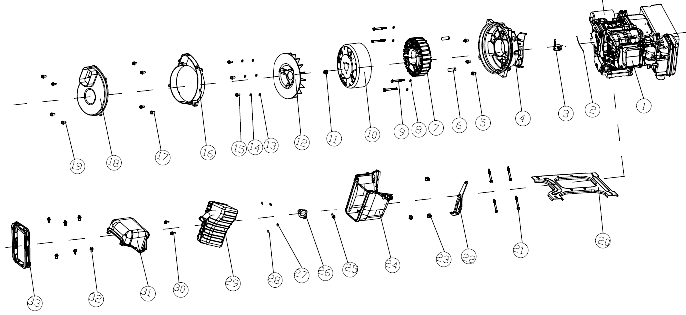
序号  NO. | 零部件编码  Part NO. | 零部件名称 Description |  |  |  |  |  | 数量QTY
序号  NO. | 零部件编码  Part NO. | 中文 |  | Part name |  | Price (USD) |  |  | SC4000i |  | N.W.（kg）/PC
1 | 20260-02556-04 | SV230-变频机动力 |  | Engine SV230, invertor engine |  |  |  |  | 1
2 | 33138-00018-00 | 橡胶密封条 |  | Rubber seal |  |  |  |  | 1
3 | 33277-00008-00 | 接线板 |  | terminal board |  |  |  |  | 1
4 | 33191-00116-00 | 电机罩 |  | Alternator cover |  |  |  |  | 1
5 | 30101-00359-00 | 六角法兰面螺栓 |  | Hex bolt |  |  |  |  | 4
6 | 34006-00001-00 | 定位销 |  | Locating pin |  |  |  |  | 2
7 | 20005-00083-00 | 变频电机定子 |  | Stator assy, invertor generator |  |  |  |  | 1
8 | 30139-00017-00 | 弹簧垫圈 |  | Spring washer |  |  |  |  | 4
9 | 30113-00105-00 | 内六角圆柱头螺钉 |  | Hex Bolt |  |  |  |  | 4
10 | 20006-00026-00 | 变频电机转子 |  | Rotor assy，invertor generator |  |  |  |  | 1
11 | 30125-00011-00 | 六角法兰面螺母 |  | hex nuts |  |  |  |  | 1
12 | 33155-00043-00 | 风扇 |  | Fan |  |  |  |  | 1
13 | 30136-00094-00 | 平垫圈 |  | Flat washer |  |  |  |  | 3
14 | 30139-00034-00 | 弹簧垫圈 |  | Spring washer |  |  |  |  | 3
15 | 30101-00405-00 | 六角法兰面螺栓 |  | hex bolt |  |  |  |  | 3
16 | 34021-00161-00 | 电机导风罩 |  | Alternator hood |  |  |  |  | 1
17 | 30101-00405-00 | 六角法兰面螺栓 |  | hex bolt |  |  |  |  | 4
18 | 33014-00603-00 | 电机后罩 |  | Alternator rear cover |  |  |  |  | 1
19 | 30101-00329-00 | 六角法兰面螺栓 |  | hex bolt |  |  |  |  | 4
20 | 33089-00077-00 | 动力支撑板 |  | Power support plate |  |  |  |  | 1
21 | 30101-00369-00 | 六角法兰面螺栓 |  | hex bolt |  |  |  |  | 4
22 | 33014-00419-00 | 支撑板 |  | Support plate |  |  |  |  | 1
23 | 30125-00023-00 | 六角法兰面螺母 |  | hex nut |  |  |  |  | 3
24 | 33013-00215-00 | 消声器排风下罩 |  | Muffler air exhaust cover |  |  |  |  | 1
25 | 30101-00407-00 | 六角法兰面螺栓 |  | hex bolt |  |  |  |  | 1
26 | 33048-00210-00 | 消声器垫片 |  | Muffler washer |  |  |  |  | 2
27 | 30139-00036-00 | 弹簧垫圈 |  | Spring washer |  |  |  |  | 2
28 | 30121-00007-00 | 六角法兰面螺母 |  | hex nut |  |  |  |  | 2
29 | 20202-00522-00 | 消声器部件 |  | Muffler components |  |  |  |  | 1
30 | 30101-00398-00 | 六角法兰面螺栓 |  | hex bolt |  |  |  |  | 2
31 | 33013-00214-00 | 消声器前罩 |  | Muffler front cover |  |  |  |  | 1
32 | 30101-00329-00 | 六角法兰面螺栓 |  | hex bolt |  |  |  |  | 6
33 | 33015-00063-00- | 出气口胶套 |  | Outlet rubber sleeve |  |  |  |  | 1
E-02 覆盖件组件Overlay component
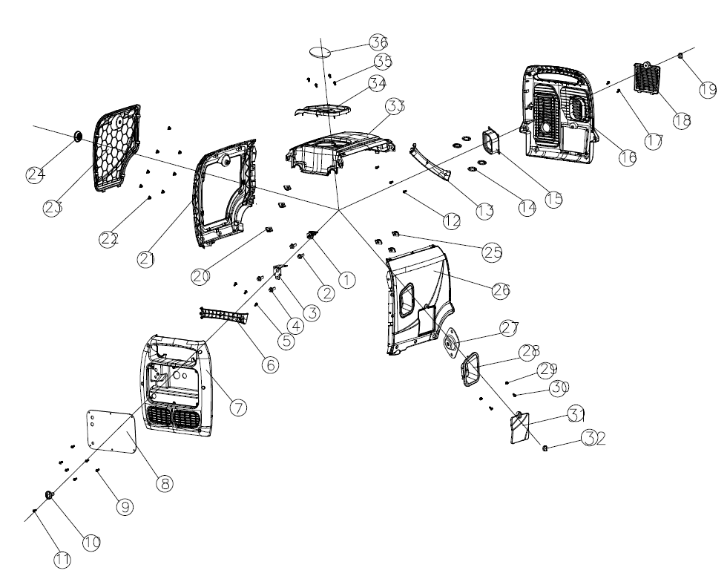

序号  NO. | 零部件编码  Part NO. | 零部件名称 Description |  |  |  |  | 数量QTY
序号  NO. | 零部件编码  Part NO. | 中文 | Part name |  | Price (USD) |  |  |  |  | SC4000i |  | N.W.（kg）/PC
1 | 20133-00001-00 | 油开关 | Fuel tank switch |  |  |  |  |  |  | 1
2 | 30101-00398-00 | 六角法兰面螺栓 | hex bolt |  |  |  |  |  |  | 2
3 | 33593-00072-00 | 固定板 | Locating plate |  |  |  |  |  |  | 1
4 | 30101-00329-00 | 六角法兰面螺栓 | hex bolt |  |  |  |  |  |  | 2
5 |  | 自攻螺丝 | grub screw |  |  |  |  |  |  | 3
6 | 20135-00233-00 | 提手后盖 | Grip back cap |  |  |  |  |  |  | 1
7 | 20114-04948-00 | 控制面板总成 | Control panel assy |  |  |  |  |  |  | 1
8 | 20114-04948-00 | 控制面板总成
9 | 30111-00008-00 | 十字槽盘头螺钉 | Cross-type screw |  |  |  |  |  |  | 6
10 | 31026-00119-00 | 燃油开关旋钮 | Fuel tap button |  |  |  |  |  |  | 1
11 | 30111-00070-00 | 十字槽盘头螺钉 | Cross-type screw |  |  |  |  |  |  | 1
12 |  | 自攻螺丝 | grub screw |  |  |  |  |  |  | 3
13 | 20135-00234-00 | 提手后盖 | Grip back cap |  |  |  |  |  |  | 1
14 | 30150-00026-00 | 孔用钢丝挡圈 | internal circlip |  |  |  |  |  |  | 4
15 | 33015-00073-00 | 电机胶套 | Motor rubber sleeve |  |  |  |  |  |  | 1
16 | 33013-00159-00 | 出气盖板总成 | Air outlet cover assy |  |  |  |  |  |  | 1
17 | 30111-00088-00 | 十字槽盘头螺钉 | Cross-type screw |  |  |  |  |  |  | 1
18 | 33014-00605-00 | 电池护板 | Battery guard |  |  |  |  |  |  | 1
19 | 31026-00144-00 | 旋钮螺栓 | knob bolts |  |  |  |  |  |  | 1
20 | 70009-00067-00 | 夹片螺母 | Clamp nut |  |  |  |  |  |  | 3
21 | 33013-00212-00 | 左壳总成 | Left shell assy |  |  |  |  |  |  | 1
22 | 70009-00317-00 | 弹簧夹片 | Spring clamp |  |  |  |  |  |  | 8
23 | 33013-00216-00 | 维修盖板 | Access cover |  |  |  |  |  |  | 1
24 | 31026-00145-00 | 旋钮 | knob |  |  |  |  |  |  | 1
25 | 70009-00067-00 | 夹片螺母 | Clamp nut |  |  |  |  |  |  | 3
26 | 33013-00309-00 | 机器右壳 | Right shell Assy |  |  |  |  |  |  | 1
27 | 33593-00106-00 | 手柄挡块 | Handle stop |  |  |  |  |  |  | 1
28 | 33014-00686-00 | 启动保护圈 | Start backup ring |  |  |  |  |  |  | 1
29 | 30125-00008-00 | 六角法兰面螺母 | hex nut |  |  |  |  |  |  | 2
30 | 30101-00068-00 | 六角法兰面螺栓 | hex bolt |  |  |  |  |  |  | 2
31 | 33013-00213-00 | 机油窗盖板 | Engine oil cover plane |  |  |  |  |  |  | 1
32 | 31026-00144-00 | 旋钮 | Knob |  |  |  |  |  |  | 1
33 | 33013-00210-00 | 上盖板 | Upper cover plane |  |  |  |  |  |  | 1
34 | 33015-00064-00 | 油箱口胶套 | Fuel tank port sleeve |  |  |  |  |  |  | 1
35 | 30111-00088-00 | 十字槽盘头螺钉 | Cross-type screw |  |  |  |  |  |  | 4
36 | 70009-00068-00 | 油位口透明块 | Oil level port transparent block |  |  |  |  |  |  | 1
E-03机架组件 Frame components

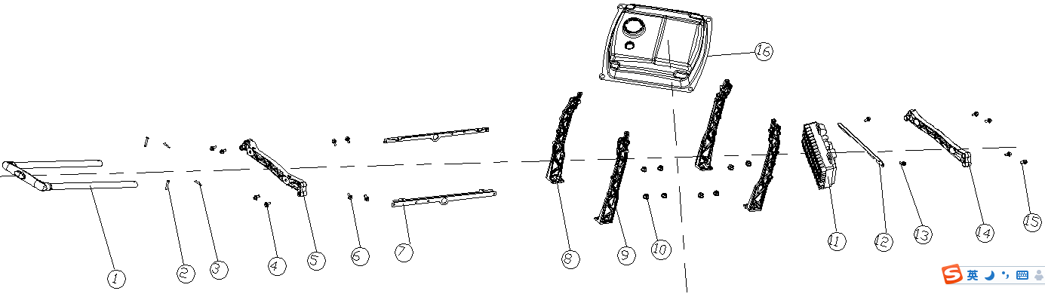

序号  NO. | 零部件编码  Part NO. | 零部件名称 Description |  |  | 数量QTY
序号  NO. | 零部件编码  Part NO. | 中文 | Part name | Price (USD) |  | SC4000i | N.W.（kg）/PC
1 | 20184-00020-00 | 拉杆总成 | Tie rod assembly |  |  | 1
2 | 34006-00057-00 | 定位插销 | Positioning latch |  |  | 2
3 | 34006-00016-00 | 定位销锁紧夹 | Locating pin locking clamp |  |  | 2
4 | 30101-00407-00 | 六角法兰面螺栓 | Hex bolts |  |  | 4
5 | 33089-00075-00 | 拉杆安装板 | Tie rod mounting plate |  |  | 1
6 | 30101-00389-00 | 六角法兰面螺栓 | Hexagon flange bolts |  |  | 4
7 | 34040-00086-00 | 油箱横梁 | Fuel tank beam |  |  | 2
8 | 33014-00417-00 | 支撑架 | Support frame |  |  | 2
9 | 33016-00416-00 | 支撑架 | Support frame |  |  | 2
10 | 30125-00023-00 | 六角法兰面螺栓 | Hex bolts |  |  | 8
11 | 20136-00135-00 | 逆变器部件 | Inverter components |  |  | 1
12 | 20114-00174-00 | 逆变器固定支架 | Inverter fixing support |  |  | 1
13 | 30101-00398-00 | 六角法兰面螺栓 | Hex bolts |  |  | 2
14 | 33089-00111-00 | 拉杆安装板 | Tie rod mounting plate |  |  | 1
15 | 30101-00407-00 | 六角法兰面螺栓 | Hex bolts |  |  | 4
16 | 20130-00422-00 | 燃油箱总成 | Fuel tank assembly |  |  | 1

E-04底板组件 Base plate assembly
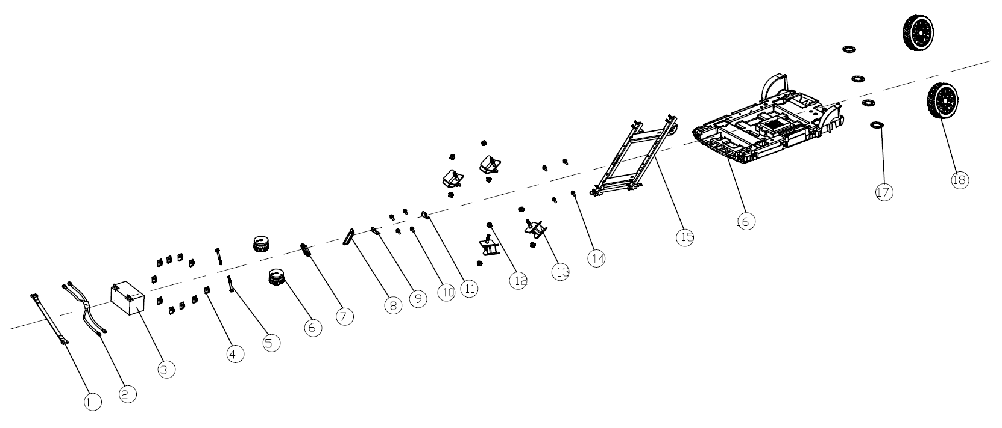
序号  NO. | 零部件编码  Part NO. | 零部件名称 Description |  |  | 数量QTY
序号  NO. | 零部件编码  Part NO. | 中文 | Part Name | Price (USD) |  | SC4000i | N.W.（kg）/PC
1 | 70002-02285-00 | 蓄电池箍带 | Battery strap |  |  | 1
2 | 20196-01211-00 | 线束部件 | wire harness |  |  | 1
3 | 31002-00019-00 | 蓄电池 | battery |  |  | 1
4 | 34024-00064-00 | 夹片螺母 | Clamp nut |  |  | 10
5 | 30101-00359-00 | 六角法兰面螺栓 | Hex bolts |  |  | 2
6 | 34030-00136-00 | 减震脚垫 | Shock Absorber gasket |  |  | 2
7 | 33015-00075-00 | 密封胶套 | Sealing rubber sleeve |  |  | 1
8 | 33015-00074-00 | 机油口胶套 | Engine oil port rubber sleeve |  |  | 1
9 | 33593-00070-00 | 固定板 | Fixed plate |  |  | 1
10 | 30101-00398-00 | 六角法兰面螺栓 | Hex bolts |  |  | 4
11 | 33593-00079-00 | 固定板 | Fixed plate |  |  | 1
12 | 30125-00023-00 | 六角法兰面螺母 | Hex nut |  |  | 8
13 | 34030-00101-00 | 减震座 | Shock absorber mount |  |  | 4
14 | 30101-00398-00 | 六角法兰面螺栓 | Hex bolts |  |  | 4
15 | 20014-00121-00 | 底板支架 | Base plane bracket |  |  | 1
16 | 33089-00074-00 | 动力底板 | Engine Power base plane |  |  | 1
17 | 20134-00135-01 | 轮子总成 | Wheel assembly |  |  | 2
18 | 30150-00045-00 | 轴用弹性挡圈 | Circlip for shaft |  |  | 4

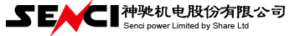
型号:SC4000iE-O
机型代码：10003-00891-00
3.5kW拉杆式静音变频机O款机组零件图册
编制： 校对： 会签： 审核： 批准：

