Engine

E-01 气缸头组件………………………2～3 E-07 反冲启动器总成………………………10~11 Cylinder head components Recoil starter Assy
E-02 箱体组件…………………………4～5 E-08调速控制机构……………………….....…12
Crankcase assy Speed governor
E-03 左箱盖……………………………6 E-09飞轮……………………………....….……13

Left Crankcase cover Flywheel
E-04 曲轴、活塞连杆总成……………7 E-10空气滤清器总成………………….....…….14
Crankshaft piston & piston rod Air cleaner
E-05 凸轮轴（配气机构）……………8 E-11电机 ………………….....……. 15-16

Camshaft Alternator
E-06 化油器总成………………………9

Carburetor

E-01气缸头组件 Cylinder head
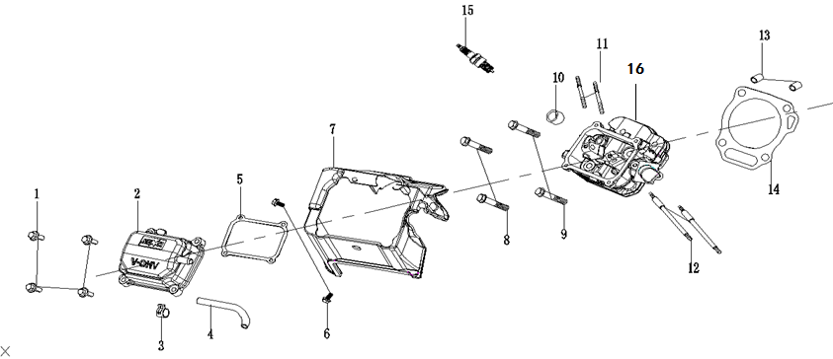
序号  NO. | 零部件编码  Part NO. | 零部件名称 Description |  |  | 数量QTY
序号  NO. | 零部件编码  Part NO. | 中文 | Part name | Price (USD) | SV230 |  | Unit price
1 | 30101-00282-00 | 螺栓M6×20 | Bolt |  | 4
2 | 20021-00015-00 | 气缸盖组件 | Cylinder cover |  | 1
3 | 34024-00027-00 | 卡箍/B12 | clamp |  | 1
4 | 34023-00110-01 | 废气管 | Exhaust pipe |  | 1
5 | 33048-00025-00 | 缸头盖密封垫 | Cylinder cover gasket |  | 1
6 | 30101-00281-00 | 六角法兰面螺栓M6*12 | Hex bolt |  | 3
7 | 34021-00046-01 | 缸头导风罩 | Cylinder head wind shield |  | 1
8 | 30101-00469-01 | 六角法兰面螺栓M8*70 | Hex bolt |  | 2
9 | 30101-00464-01 | 六角法兰面螺栓M8*50 | Hex bolt |  | 2

E-01气缸头组件 Cylinder head
序号  NO. | 零部件编码  Part NO. | 零部件名称 Description |  |  | 数量QTY
序号  NO. | 零部件编码  Part NO. | 中文 | Part name | Price (USD) | SV230 |  | N.W.（kg）/PC
10 | 34018-00005-01 | 进气门挡油罩 | Intake valve oil cover |  | 1
11 | 30110-00027-01 | 排气双头螺栓 | Air exhaust double-head bolt |  | 2
12 | 30110-00018-00 | 进气双头螺栓 | Air intake double-head bolt |  | 2
13 | 34006-00009-00 | 定位销 | positioning pin |  | 2
14 | 33048-00032-00 | 汽缸头密封垫 | Cylinder head gasket |  | 1
15 | 20027-00008-00 | 火花塞部件 | Spark plug |  | 1
16 | 20023-00025-00 | 汽缸头总成 | Cylinder head assy |  | 1

E-02 箱体组件 Crankcase assy
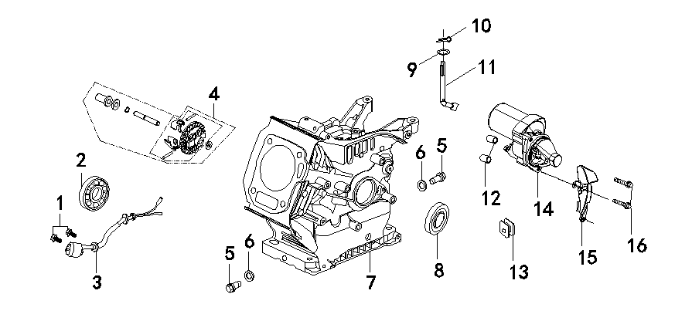
序号  NO. | 零部件编码  Part NO. | 零部件名称 Description |  |  |  |  |  |  |  |  | 数量QTY
序号  NO. | 零部件编码  Part NO. | 中文 |  |  | Part name |  |  | Price (USD) |  |  | SV230 |  |  |  | N.W.（kg）/PC
1 | 30101-00277-00 | 螺栓M6×16 |  |  | bolt |  |  |  |  |  | 2
2 | 30141-00155-00 | 轴承TM6205E |  |  | Bearing TM6205E |  |  |  |  |  | 1
3 | 33247-00005-01 | 机油传感器 |  |  | Oil sensor |  |  |  |  |  | 1
5 | 30101-00487-01 | 放油螺钉 |  |  | Bleeding screw |  |  |  |  |  | 2
6 | 30136-00078-01 | 铝垫片 |  |  | Alum pad |  |  |  |  |  | 2
7 | 34011-00117-00 | 曲轴箱体 |  |  | crankcase |  |  |  |  |  | 1
8 | 34007-00003-01 | 油封 25×41.25×6 |  |  | Oil seal |  |  |  |  |  | 1
E-02 箱体组件 Crankcase assy
序号  NO. | 零部件编码  Part NO. | 零部件名称 Description |  |  |  |  |  |  | 数量QTY
序号  NO. | 零部件编码  Part NO. | 中文 |  | Part name |  | Price (USD) |  |  | SV230 |  |  |  |  |  |  |  | N.W.（kg）/PC
12 | 34006-00001-00 | 定位销 |  | Positioning pin |  |  |  |  | 1
14 | 20149-00075-01 | 启动电机 |  | Starting motor |  |  |  |  | 1
15 | 34021-00005-01 | 侧挡风板 |  | Side wind shield |  |  |  |  | 1
16 | 30101-00410-01 | 六角法兰面螺栓 |  | Hex bolt |  |  |  |  | 2
E-03 曲轴箱盖Crankcase cover
序号  NO. | 零部件编码  Part NO. | 零部件名称 Description |  |  |  |  |  |  |  | 数量QTY
序号  NO. | 零部件编码  Part NO. | 中文 | Part name |  |  |  | Price (USD) |  |  | SV230 |  |  |  |  |  | N.W.（kg）/PC
1 | 34007-00003-01 | 油封Ф25×Ф41.25×6 | Oil seal |  |  |  |  |  |  | 1
2 | 20026-00016-02 | 机油塞 | Oil choke plug |  |  |  |  |  |  | 1
3 |  | 密封圈 | Gasket ring |  |  |  |  |  |  | 1
4 | 30101-00279-00 | 合箱螺栓M8*32 | Assembling bolt |  |  |  |  |  |  | 7
5 | 33129-00013-00 | 曲轴箱盖 | Crankcase cover |  |  |  |  |  |  | 1
6 |  | 密封圈 | Gasket ring |  |  |  |  |  |  | 1
7 | 20026-00001-02 | 机油尺 | Oil rule |  |  |  |  |  |  | 1
8 | 30141-00155-00 | 轴承TM6205E | Breaings TM6205E |  |  |  |  |  |  | 1
9 | 34006-00001-00 | 定位销 | Positioning pin |  |  |  |  |  |  | 2
10 | 33048-00184-00 | 合箱纸垫 | Assembling paper pad |  |  |  |  |  |  | 1

E-04曲轴活塞连杆总成 Crankshaft piston
序号  NO. | 零部件编码  Part NO. | 零部件名称 Description |  |  | 数量QTY
序号  NO. | 零部件编码  Part NO. | 中文 | Part name | Price (USD) | SV230 |  | N.W.（kg）/PC
1 | 20084-00005-00 | 活塞环组合 | Piston ring units |  | 1
2 | 30150-00022-00 | 活塞销卡圈 | piston pin clamping ring |  | 2
3 | 34004-00011-00 | 活塞 | piston |  | 1
4 | 34006-00013-00 | 活塞销 | Piston pin |  | 1
5 | 20008-00005-00 | 连杆总成 | connecting rod assy |  | 1
6 |  | 连杆大头连接螺钉 | connnecting rod big end bolt |  | 2
7 | 20011-00069-00 | 曲轴总成 | crankshaft assy |  | 1
8 | 70009-00075-00 | 半圆键 | half round key |  | 1

E-05凸轮轴（配气结构）Camshaft
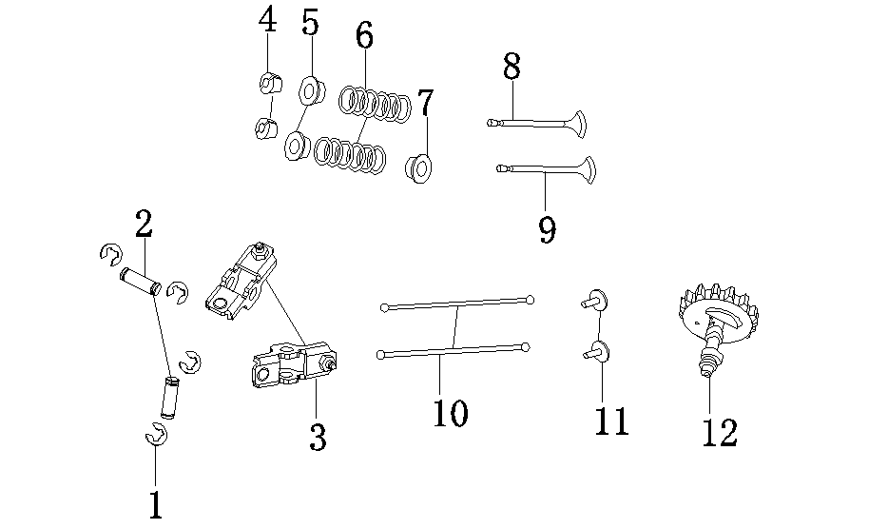
序号  NO. |  | 零部件编码  Part NO. |  | 零部件名称 Description |  |  |  |  |  |  |  |  |  |  | 数量QTY
 |  |  |  | 中文 |  | Part name |  |  |  | Price (USD) |  |  |  |  | SV230 |  |  |  |  |  |  | N.W.（kg）/PC
1 |  | 30150-00028-00 |  | 轴用弹性挡圈 |  | circlip for shaft |  |  |  |  |  |  |  |  | 4
2 |  | 30134-00007-00 |  | 摇臂轴 |  | rock arm shaft |  |  |  |  |  |  |  |  | 2
3 |  | 34019-00008-00 |  | 气门摇臂组件 |  | arm rocker components |  |  |  |  |  |  |  |  | 2
4 |  | 34016-00011-00 |  | 气门锁夹 |  | Air valve lock clip |  |  |  |  |  |  |  |  | 4
5 |  | 34016-00010-00 |  | 气门弹簧座 |  | Air valve spring mount |  |  |  |  |  |  |  |  | 2
6 |  | 34015-00003-00 |  | 气门弹簧 |  | Air valve spring |  |  |  |  |  |  |  |  | 2
7 |  | 34018-00005-01 |  | 进气门挡油罩 |  | Air intake valve oil shield |  |  |  |  |  |  |  |  | 1
8 |  | 34013-00037-00 |  | 排气门 |  | intake valve |  |  |  |  |  |  |  |  | 1
9 |  | 34013-00035-00 |  | 进气门 |  | exhaust valve |  |  |  |  |  |  |  |  | 1
10 |  | 34020-00007-00 |  | 气门推杆 |  | valve push rod |  |  |  |  |  |  |  |  | 2
11 |  | 34008-00004-00 |  | 气门挺柱 |  | valve top post |  |  |  |  |  |  |  |  | 2
12 |  | 20012-00011-00 |  | 凸轮轴总成 |  | Camshaft assy |  |  |  |  |  |  |  |  | 1
E-06 化油器总成 Carburetor
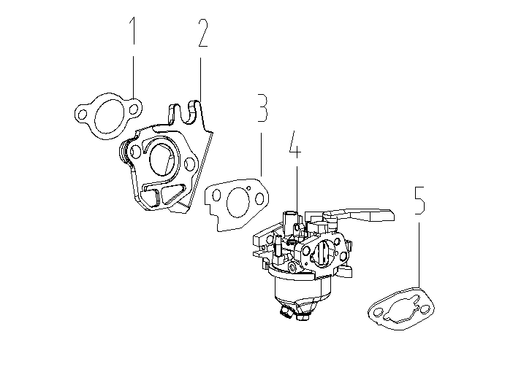
序号  NO. |  | 零部件编码  Part NO. |  | 零部件名称 Description |  |  |  |  |  |  |  |  | 数量QTY
 |  |  |  | 中文 |  | Part name |  |  |  |  | Price (USD) |  | SV230 |  |  |  |  |  |  |  | N.W.（kg）/PC
1 |  | 33048-00051-00 |  | 进气口密封垫 |  | air intake filler plate |  |  |  |  |  |  | 1
2 |  | 34012-00015-01 |  | 化油器连接块 |  | Carburetor link block |  |  |  |  |  |  | 1
3 |  | 33048-00076-00 |  | 化油器垫片 |  | Carburetor gasket |  |  |  |  |  |  | 1
4 |  | 20024-00317-00 |  | 化油器总成 |  | Carburetor assy |  |  |  |  |  |  | 1
5 |  | 33048-00045-01 |  | 空滤器密封垫 |  | Air filter assy |  |  |  |  |  |  | 1
E-07 反冲起动器总成 Recoil starter
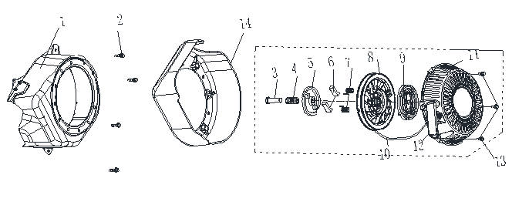

 | 序号  NO. |  | 零部件编码  Part NO. | 零部件名称 Description |  |  |  |  |  |  |  | 数量QTY
 |  |  | 零部件编码  Part NO. | 中文 |  |  | Part name | Price (USD) |  |  |  | SV230 |  |  |  |  |  |  |  | N.W.（kg）/PC
 | 1 |  | 20010-00115-01 | 反冲启动器外罩 |  |  | Recoil start outer cover |  |  |  |  | 1
 | 2 |  | 30101-00281-00 | 六角发烂漫螺栓M6*12 |  |  | Hex bolt |  |  |  |  | 4
 | 3 |  |  | 轴位螺钉 |  |  | Shaft location bolt |  |  |  |  | 1
 | 4 |  |  | 启动弹簧 |  |  | Starting spring |  |  |  |  | 1
 | 5 |  |  | 棘爪导板 |  |  | Pawl guide board |  |  |  |  | 1
 | 6 |  |  | 棘爪 |  |  | pawl |  |  |  |  | 2
 | 7 |  |  | 复位弹簧 |  |  | Reset spring |  |  |  |  | 2
E-07 反冲起动器总成 Recoil starter

序号  NO. |  | 零部件编码  Part NO. |  | 零部件名称 Description |  |  |  |  |  |  |  |  |  | 数量QTY
 |  |  |  | 中文 | Part name |  |  |  | Price (USD) |  |  |  |  | SV230 |  |  |  |  |  |  |  |  | N.W.（kg）/PC
8 |  |  |  | 卷轴 | roller |  |  |  |  |  |  |  |  | 1
9 |  |  |  | 启动器盘簧 | Starter coil spring |  |  |  |  |  |  |  |  | 1
10 |  |  |  | 启动拉绳 | Starting pull rope |  |  |  |  |  |  |  |  | 1
11 |  | 20034-00046-01 |  | 启动器拉盘 | Recoil starter |  |  |  |  |  |  |  |  | 1
12 |  | 20184-00015-01 |  | 拉手 | Handle bar |  |  |  |  |  |  |  |  | 1
13 |  | 30101-00662-01 |  | 六角法兰面螺栓/M6 | Hex bolt |  |  |  |  |  |  |  |  | 3
 |  |  |  |  |  |  |  |  |  |  |  |  |  | 1

E-9飞轮Flywheel
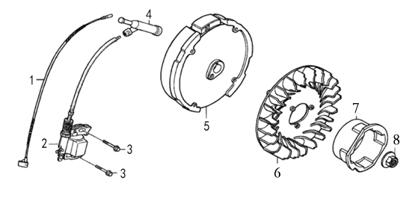
序号  NO. | 零部件编码  Part NO. | 零部件名称 Description |  |  |  |  |  | 数量QTY
序号  NO. | 零部件编码  Part NO. | 中文 |  | Part name |  | Price(USD) |  | SV230 |  |  |  | N.W.（kg）/PC
2 | 20028-00051-01 | 点火器总成 |  | ignition coil assy |  |  |  | 1
3 | 30101-00283-00 | 螺栓M6×25 |  | bolt |  |  |  | 2
5 | 33099-00038-00 | 飞轮组合 |  | Flywheel |  |  |  | 1
6 | 33155-00053-01 | 风扇 |  | fan |  |  |  | 1
7 | 34022-00031-01 | 启动杯 |  | Starter |  |  |  | 1
8 | 30125-00011-01 | 螺母M14 |  | nut |  |  |  | 1
E-10 空气滤清器 Air cleaner
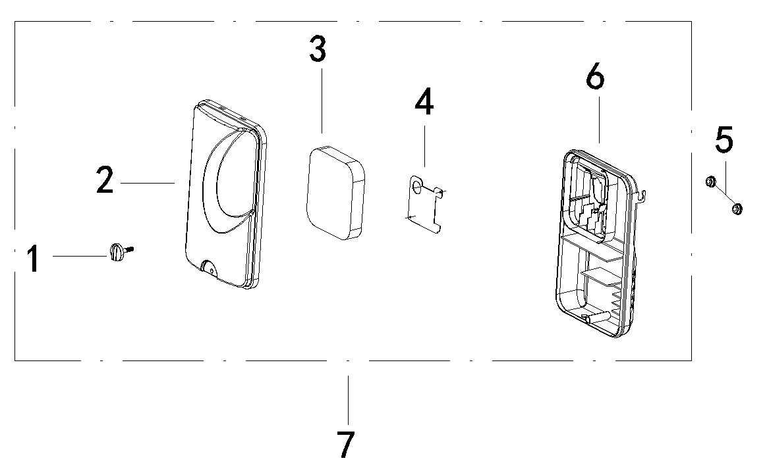
序号  NO. | 零部件编码  Part NO. | 零部件名称 Description |  |  |  |  | 数量QTY
序号  NO. | 零部件编码  Part NO. | 中文 | English |  | Price (USD) |  | SV230 |  |  |  | N.W.（kg）/PC
1 |  | 螺栓 | BOLT,BUTTERFLY |  |  |  | 1
2 |  | 空滤器盖组件 | COVER,AIR CLEANER |  |  |  | 1
3 | 70002-02766-00 | 空滤器滤芯 | ELEMENT ASSY,AIR CLEANER |  |  |  | 1
4 |  | 金属挡板 | PLATE |  |  |  | 1
5 | 30125-00013-00 | 带盘螺母 | NUT,BUTTERFLY |  |  |  | 2
6 |  | 座体组合 | ELBOW COMP,AIR CLEANER |  |  |  | 1
7 | 20025-00160-00 | 空滤器总成 | AIR CLEANER ASSY |  |  |  | 1

E-11 电机 Alternator
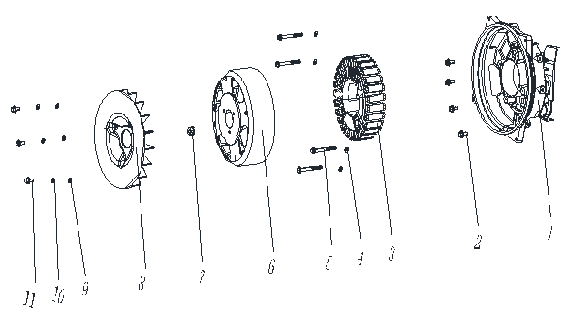

序号  NO. | 零部件编码  Part NO. | 零部件名称 Description |  |  | 数量QTY
序号  NO. | 零部件编码  Part NO. | 中文 | Part name | Price (USD) | SV230 |  | N.W.（kg）/PC
1 | 33191-00140-00 | 电机罩 | Alternator cover |  | 1
2 | 30101-00359-01 | 六角法兰面螺栓/M8 | Hex bolt |  | 4
4 | 30139-00034-01 | 弹簧垫圈/Φ6/ | Spring gasket |  | 4
5 | 30113-00105-01 | 内六角圆柱头螺钉/M6 | Hex bolt |  | 4
6 | 20004-00048-00 | 变频电机 | Inverter motor |  | 1
7 | 30125-00011-01 | 六角法兰面螺母/M14 | Hex nut |  | 1

E-11 电机 Alternator

序号  NO. | 零部件编码  Part NO. | 零部件名称 Description |  |  | 数量QTY
序号  NO. | 零部件编码  Part NO. | 中文 | Part name | Price (USD) | SV230 |  | N.W.（kg）/PC
8 | 33155-00043-01 | 风扇/ | Fan |  | 1
9 | 30136-00092-01 | 摆杆垫片/Φ6 | Rocker pad |  | 3
10 | 30139-00034-01 | 弹簧垫圈/Φ6/ | Spring gasket |  | 3
11 | 30101-00405-01 | 六角法兰面螺栓/M6 | Hex bolt |  | 3

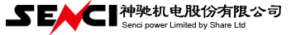
变频机动力零件图册
型号：SV230
编制： 校对： 会签： 审核： 批准：

