1.6KW简易款变频机组零件图册

1.6KW SUA2000i Inverter Generator Genset Explosive View

机组：10003-00894-00
型号Model Name：SUA2000i

编制： 校对： 会签： 审核： 批准：

1.6KW简易款变频机组零件图册
E-01 整机爆炸图 Genset Explosvie View………………………4
E-02 机器前壳总成爆炸图 Front Case Assy Explosive View………………………5
E-03 机器后壳总成爆炸图 Rear Case Assy Explovise View…………………………..6
E-04 逆变器进气盖板总成……………………….....7
Inverter air intake cover plate Assy
E-05 消声器出气盖板总成……………………8
Muffler outlet cover plate assembly
E-06 动力底板总成……………………9
Engine Power backplane assembly
E-07 燃油箱总成……………………10
Fuel tank assembly
E-08 发动机总成……………………11
Engine assembly
E-09 逆变器总成…………………12
Inverter assembly
E-10 三合一开关总成…………………13
Three in one switch assembly

E-01 整机爆炸图 Genset Explosive View
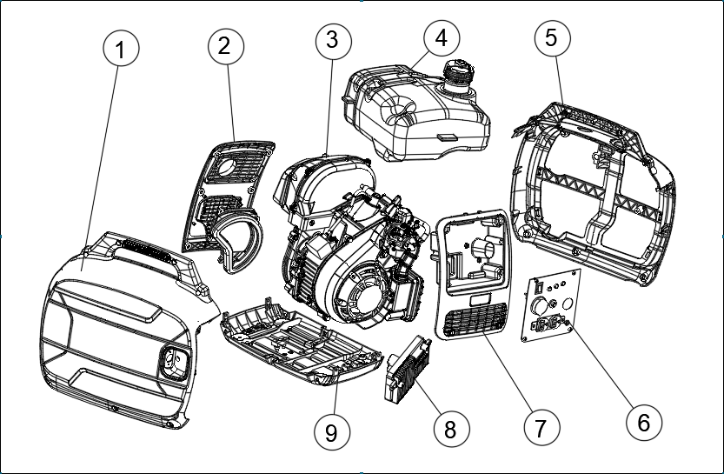
序号  NO. | 零部件编码  Part NO. | 零部件名称 Description |  |  | 数量QTY
序号  NO. | 零部件编码  Part NO. | 中文 | Part Name | Price (USD) |  | SUA2000i | N.W.（kg）/PC
1 | 33013-00202-00 | 机器前壳总成 | Front cover assy |  |  | 1
2 | 33013-00116-01 | 消声器出气盖板总成 | Muffler exhaust cover assy |  |  | 1
3 | 20260-01168-19 | 动力总成 | Engine assy |  |  | 1
4 | 20130-00411-00 | 燃油箱总成 | Fuel tank assy |  |  | 1
5 | 33013-00203-00 | 机器后壳总成 | Rear cover assy |  |  | 1
6 | 20114-04936-00 | 控制面板总成 | Control panel assy |  |  | 1
7 | 33013-00080-01 | 逆变器进气盖板总成 | Inverter air intake cover assy |  |  | 1
8 | 20136-00132-00 | 逆变器总成 | Inverter assy |  |  | 1
9 | 33089-00073-00 | 动力底板总成 | Engine Power Bottom cover assy |  |  | 1

E-02 机器前壳总成爆炸图/Before the machine shell exploded assembly diagram
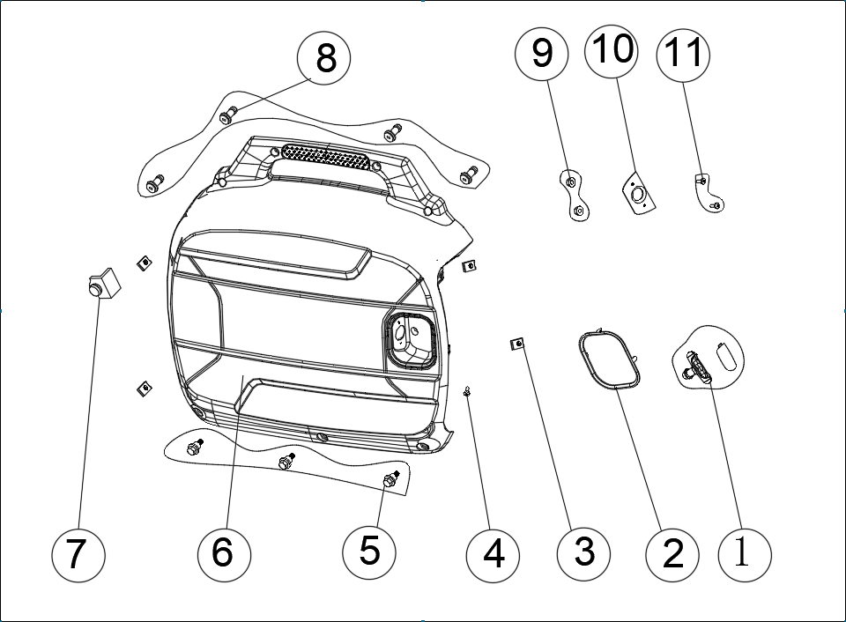
序号  NO. | 零部件编码  Part NO. | 零部件名称 Description |  |  | 数量QTY
序号  NO. | 零部件编码  Part NO. | 中文 | Part Name | Price (USD) |  | SUA2000i | N.W.（kg）/PC
1 | 70010-00079-00 | 启动拉手 | Handle crip |  |  | 1
2 | 33014-00081-01 | 启动保护圈 | Start protection |  |  | 1
3 | 34024-00105-00 | 夹片螺母 | Lock clip |  |  | 4
4 | 30111-00027-00 | 十字槽盘头螺钉 | Pan head screws with cross recess |  |  | 1
5 | 30114-00033-01 | 内六角盘头螺栓 | hexagon socket-head bolt |  |  | 3
6 | 33013-00173-00 | 机器前壳 | Front panel |  |  | 1
7 | 33275-00111-00 | 缸头定位垫 | Cylinder head fix washer |  |  | 1
8 | 30111-00088-01 | 十字槽盘头螺钉M5×14 | Pan head screws with cross recess |  |  | 4
9 | 30125-00015-00 | 六角法兰面螺母M3 | Hexagon nuts with flange M3 |  |  | 2
10 | 33593-00019-00 | 手柄挡块 | Handle baffle |  |  | 1
11 | 30111-00071-00 | 十字槽盘头螺钉M3X8 | Pan head screws with cross recess |  |  | 2

E-03机器后壳总成爆炸图/ Front Case Assy Explosive View
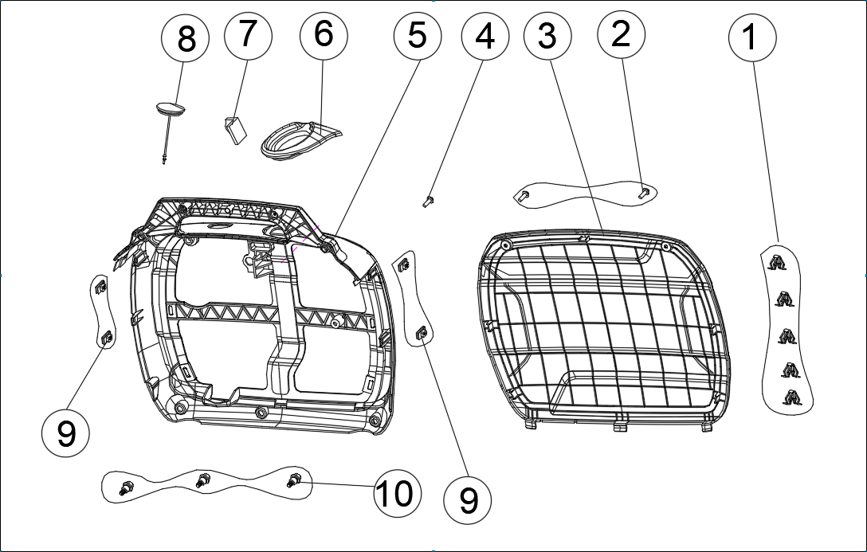
序号  NO. | 零部件编码  Part NO. |  | 零部件名称 Description |  |  |  |  |  |  |  |  |  |  |  |  |  |  |  |  |  |  |  |  |  |  |  | 数量QTY
序号  NO. |  |  | 中文 |  |  |  |  |  |  | Part Name |  |  |  |  |  |  |  |  | Price (USD) |  |  |  |  |  |  |  |  |  |  | SUA2000i |  | N.W.（kg）/PC
1 | 70009-00317-00 |  | 弹簧夹片 |  |  |  |  |  |  | Spring clamp |  |  |  |  |  |  |  |  |  |  |  |  |  |  |  |  |  |  |  | 5
2 | 30111-00088-01 |  | 十字槽盘头螺钉 M5×14 |  |  |  |  |  |  | cross recessed pan head screw |  |  |  |  |  |  |  |  |  |  |  |  |  |  |  |  |  |  |  | 2
3 | 33013-00204-00 |  | 后盖板 |  |  |  |  |  |  | Rear cover |  |  |  |  |  |  |  |  |  |  |  |  |  |  |  |  |  |  |  | 1
4 | 30111-00027-01 |  | 十字槽盘头螺钉 |  |  |  |  |  |  | cross recessed pan head screw |  |  |  |  |  |  |  |  |  |  |  |  |  |  |  |  |  |  |  | 1
5 | 33013-00174-00 |  | 机器后壳 |  |  |  |  |  |  | Genset Rear panel |  |  |  |  |  |  |  |  |  |  |  |  |  |  |  |  |  |  |  | 1
6 | 33275-00012-00 |  | 加油隔垫 |  |  |  |  |  |  | Fuel dottle pin |  |  |  |  |  |  |  |  |  |  |  |  |  |  |  |  |  |  |  | 1
7 | 33275-00111-00 |  | 缸头定位垫 |  |  |  |  |  |  | Cylinder head fixed pad |  |  |  |  |  |  |  |  |  |  |  |  |  |  |  |  |  |  |  | 1
8 | 33015-00043-00 |  | 火花塞胶套 |  |  |  |  |  |  | Rubber sleeve for spark plug |  |  |  |  |  |  |  |  |  |  |  |  |  |  |  |  |  |  |  | 1
9 | 34024-00105-00 |  | 夹片螺母 |  |  |  |  |  |  | Lock clamp |  |  |  |  |  |  |  |  |  |  |  |  |  |  |  |  |  |  |  | 4
10 | 30114-00033-01 |  | 内六角盘头螺栓 |  |  |  |  |  |  | hexagon socket-head bolt |  |  |  |  |  |  |  |  |  |  |  |  |  |  |  |  |  |  |  | 3
E-04逆变器进气盖板总成/Inverter air intake cover assembly
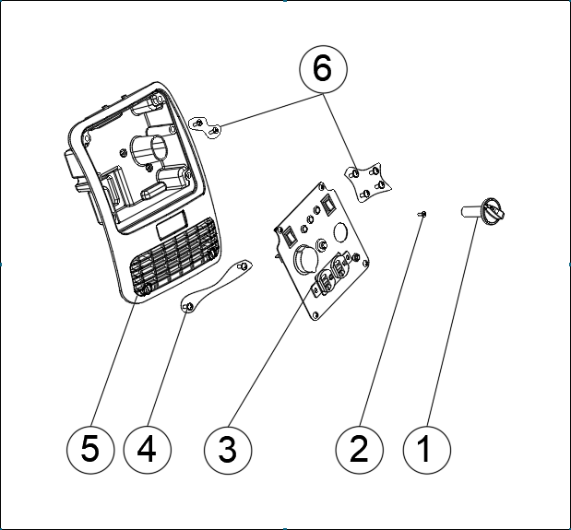
序号  NO. | 零部件编码  Part NO. |  | 零部件名称 Description |  |  |  |  |  |  |  |  |  |  |  |  |  |  |  |  |  |  |  | 数量QTY
序号  NO. |  |  | 中文 |  |  |  |  |  | Part name |  |  |  |  |  | Price (USD) |  |  |  |  |  |  |  |  |  |  |  |  | SUA2000i |  |  | N.W.（kg）/PC
1 | 31026-00121-00 |  | 开关手柄 |  |  |  |  |  | fule switch handle |  |  |  |  |  |  |  |  |  |  |  |  |  |  |  |  |  |  | 1
2 | 30111-00070-01 |  | 十字槽盘头螺钉M4×12 |  |  |  |  |  | cross recess head screw M4*12 |  |  |  |  |  |  |  |  |  |  |  |  |  |  |  |  |  |  | 1
3 | 20114-04936-00 |  | 控制面板总成 |  |  |  |  |  | Control panel assy |  |  |  |  |  |  |  |  |  |  |  |  |  |  |  |  |  |  | 1
4 | 30111-00088-01 |  | 十字槽盘头螺钉M5×14 |  |  |  |  |  | cross recess head screw M5*14 |  |  |  |  |  |  |  |  |  |  |  |  |  |  |  |  |  |  | 2
5 | 33013-00080-01 |  | 逆变器进气盖板 |  |  |  |  |  | Inverter air inlet cover |  |  |  |  |  |  |  |  |  |  |  |  |  |  |  |  |  |  | 1
6 | 30111-00085-00 |  | 十字槽盘头螺钉M5×25 |  |  |  |  |  | cross recess head screw M5*25 |  |  |  |  |  |  |  |  |  |  |  |  |  |  |  |  |  |  | 6
E-05消声器出气盖板总成/Muffler exhaust cover plate assembly
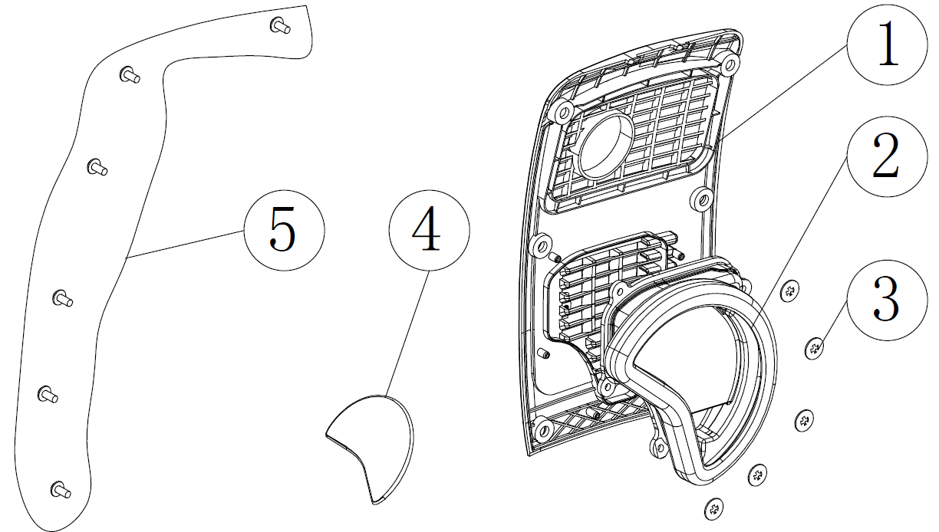
序号  NO. | 零部件编码  Part NO. |  |  | 零部件名称 Description |  |  |  |  |  |  |  |  |  |  |  |  |  |  |  |  |  |  |  | 数量QTY
序号  NO. |  |  |  | 中文 |  |  |  | English |  |  |  |  |  |  |  |  | Price (USD) |  |  |  |  |  |  |  |  |  |  | SUA2000i |  |  | N.W.（kg）/PC
1 | 33013-00093-01 |  |  | 消声器出气盖板 |  |  |  | Muffler exhaust cover assy |  |  |  |  |  |  |  |  |  |  |  |  |  |  |  |  |  |  |  | 1
2 | 33015-00026-00 |  |  | 电机胶套 |  |  |  | Alternator rubber sleeve |  |  |  |  |  |  |  |  |  |  |  |  |  |  |  |  |  |  |  | 1
3 | 30150-00026-00 |  |  | 弹簧卡紧圈 |  |  |  | Spring ring |  |  |  |  |  |  |  |  |  |  |  |  |  |  |  |  |  |  |  | 5
4 | 60007-00141-00 |  |  | 出气棉 |  |  |  | Filter pad |  |  |  |  |  |  |  |  |  |  |  |  |  |  |  |  |  |  |  | 1
5 | 30111-00088-01 |  |  | 十字槽盘头螺钉 M5×14 |  |  |  | cross recess head screw M5*14 |  |  |  |  |  |  |  |  |  |  |  |  |  |  |  |  |  |  |  | 6
E-06动力底板总成/Engine Power backplane assembly
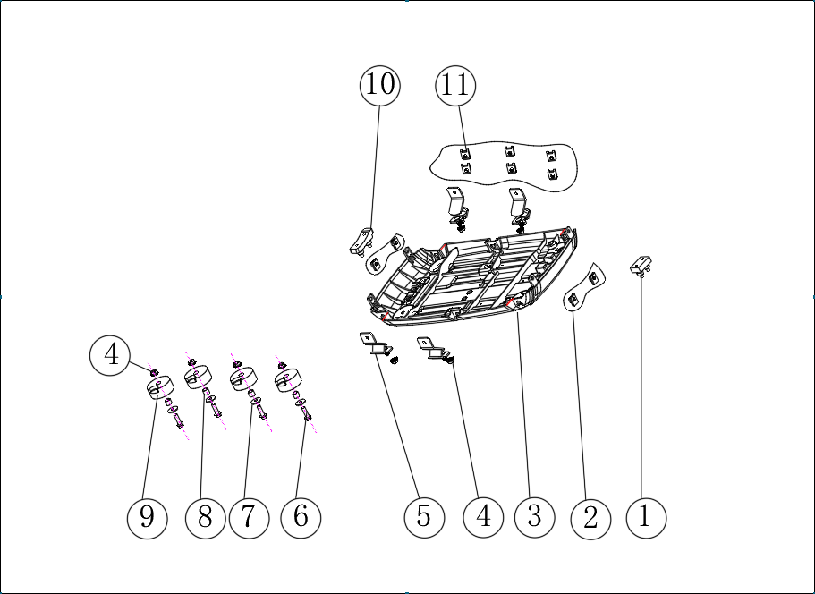
序号  NO. |  | 零部件编码  Part NO. |  |  | 零部件名称 Description |  |  |  |  |  |  |  |  |  |  |  |  |  |  | 数量QTY
 |  |  |  |  | 中文 |  | Part name |  |  |  |  | Price (USD) |  |  |  |  |  |  |  |  |  |  |  |  |  |  |  | SUA2000i |  |  | N.W.（kg）/PC
1 |  | 33275-00019-00 |  |  | 箱体底垫 |  | engine body bottom washer |  |  |  |  |  |  |  |  |  |  |  |  |  |  |  |  |  |  |  |  | 1
2 |  | 34024-00105-00 |  |  | 夹片螺母 |  | Lock clamp |  |  |  |  |  |  |  |  |  |  |  |  |  |  |  |  |  |  |  |  | 4
3 |  | 33089-00073-00 |  |  | 动力底板 |  | Engine power bottom cover |  |  |  |  |  |  |  |  |  |  |  |  |  |  |  |  |  |  |  |  | 1
4 |  | 30125-00013-00 |  |  | 六角法兰面螺母 M6 |  | hex nut M6 |  |  |  |  |  |  |  |  |  |  |  |  |  |  |  |  |  |  |  |  | 8
5 |  | 34030-00026-01 |  |  | 减振座 |  | shock absorber mount |  |  |  |  |  |  |  |  |  |  |  |  |  |  |  |  |  |  |  |  | 6
6 |  | 30101-00042-00 |  |  | 六角法兰面螺栓M6×20 |  | hex bolt M6 |  |  |  |  |  |  |  |  |  |  |  |  |  |  |  |  |  |  |  |  | 4
7 |  | 30136-00113-01 |  |  | 平垫圈 |  | Flat washer |  |  |  |  |  |  |  |  |  |  |  |  |  |  |  |  |  |  |  |  | 4
8 |  | 34032-00015-01 |  |  | 衬套Φ7*Φ10*8.5mm |  | Sleeve φ7×30×8.5 |  |  |  |  |  |  |  |  |  |  |  |  |  |  |  |  |  |  |  |  | 4
9 |  | 33275-00018-01 |  |  | 机器外壳胶垫 |  | Genset casing cushion |  |  |  |  |  |  |  |  |  |  |  |  |  |  |  |  |  |  |  |  | 4
10 |  | 33275-00006-01 |  |  | 电机胶垫 |  | Alternator cushion |  |  |  |  |  |  |  |  |  |  |  |  |  |  |  |  |  |  |  |  | 1
11 |  | 34024-00085-00 |  |  | 夹片螺母 |  | Lock clamp |  |  |  |  |  |  |  |  |  |  |  |  |  |  |  |  |  |  |  |  | 6
E-07燃油箱总成/Fuel tank assembly
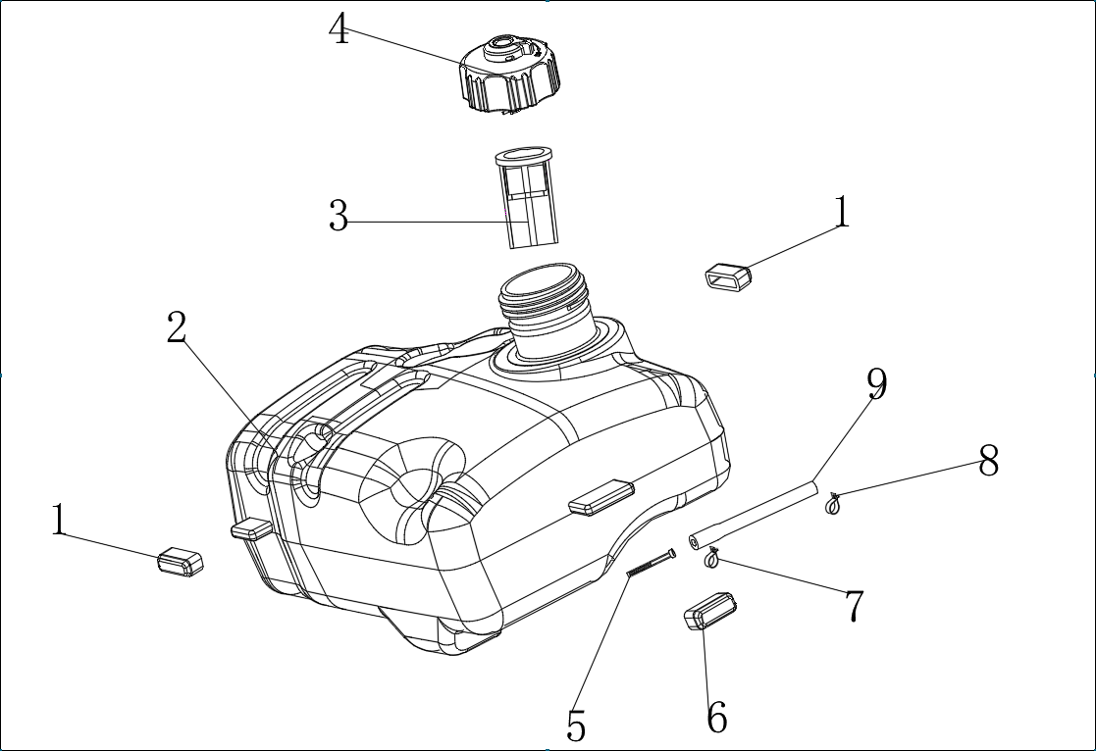
序号  NO. | 零部件编码  Part NO. |  |  | 零部件名称 Description |  |  |  |  |  |  |  |  |  |  |  |  |  |  |  |  |  | 数量QTY
序号  NO. |  |  |  | 中文 |  | Part name |  |  |  |  |  |  | Price (USD) |  |  |  |  |  |  |  |  |  |  |  |  |  |  | SUA2000i |  |  | N.W.（kg）/PC
1 | 33015-00023-01 |  |  | 油箱胶套 |  | Fuel tank Rubber sleeve |  |  |  |  |  |  |  |  |  |  |  |  |  |  |  |  |  |  |  |  |  | 2
2 | 20130-00411-00 |  |  | 燃油箱总成 |  | Fuel tank assy |  |  |  |  |  |  |  |  |  |  |  |  |  |  |  |  |  |  |  |  |  | 1
3 | 34037-00001-00 |  |  | 过滤网 |  | Filter screen |  |  |  |  |  |  |  |  |  |  |  |  |  |  |  |  |  |  |  |  |  | 1
4 | 20131-00006-00 |  |  | 燃油箱盖 |  | Fuel tank cap |  |  |  |  |  |  |  |  |  |  |  |  |  |  |  |  |  |  |  |  |  | 1
5 | 34037-00003-00 |  |  | 过滤网总成 |  | Filter screen |  |  |  |  |  |  |  |  |  |  |  |  |  |  |  |  |  |  |  |  |  | 1
6 | 33015-00066-01 |  |  | 油箱胶套 |  | Fuel tank Rubber sleeve |  |  |  |  |  |  |  |  |  |  |  |  |  |  |  |  |  |  |  |  |  | 1
7 | 34024-00027-00 |  |  | 卡箍 |  | Clamp |  |  |  |  |  |  |  |  |  |  |  |  |  |  |  |  |  |  |  |  |  | 1
8 | 34024-00032-00 |  |  | 卡箍 |  | Clamp |  |  |  |  |  |  |  |  |  |  |  |  |  |  |  |  |  |  |  |  |  | 1
9 | 34023-00114-00 |  |  | 燃油管 |  | Fuel pipe |  |  |  |  |  |  |  |  |  |  |  |  |  |  |  |  |  |  |  |  |  | 1
E-08发动机总成/Engine assembly
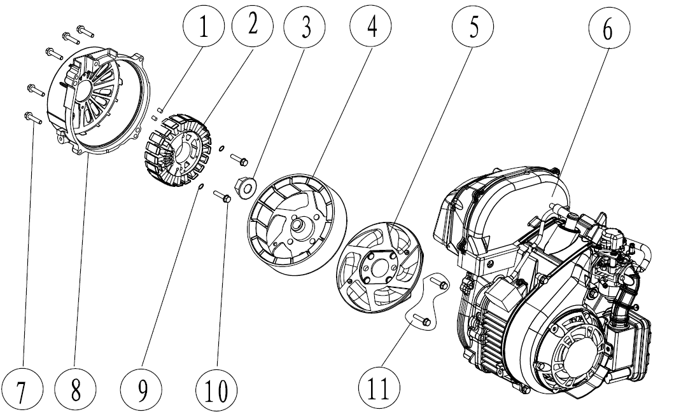
序号  NO. | 零部件编码  Part NO. |  |  | 零部件名称 Description |  |  |  |  |  |  |  |  |  |  |  |  |  |  |  |  |  |  |  |  | 数量QTY
序号  NO. |  |  |  | 中文 |  |  |  |  |  |  | Part Nanme |  |  |  |  |  |  | Price (USD) |  |  |  |  |  |  |  |  |  |  | SUA2000i |  | N.W.（kg）/PC
1 | 34006-00001-00 |  |  | 定位销/Φ8*Φ6.4*12/ |  |  |  |  |  |  | positioning pin |  |  |  |  |  |  |  |  |  |  |  |  |  |  |  |  |  | 2
2 | 20005-00078-00 |  |  | 变频电机定子/2.2KW/230V/ |  |  |  |  |  |  | Inverter Motor stator |  |  |  |  |  |  |  |  |  |  |  |  |  |  |  |  |  | 1
3 | 30125-00034-01 |  |  | 六角法兰面螺母（M12×P1.25/白锌） |  |  |  |  |  |  | Hexagon bolts |  |  |  |  |  |  |  |  |  |  |  |  |  |  |  |  |  | 1
4 | 20006-00051-00 |  |  | 变频电机转子/Φ145*44.5/ |  |  |  |  |  |  | Inverter Motor rotor |  |  |  |  |  |  |  |  |  |  |  |  |  |  |  |  |  | 1
5 | 33155-00066-01 |  |  | 冷却风扇 |  |  |  |  |  |  | Cooling fan |  |  |  |  |  |  |  |  |  |  |  |  |  |  |  |  |  | 1
6 | 20260-01168-19 |  |  | 发动机总成 |  |  |  |  |  |  | Engine assy |  |  |  |  |  |  |  |  |  |  |  |  |  |  |  |  |  | 1
7 | 30101-00284-00 |  |  | 六角法兰面螺栓（M6×30×P1.0/白锌） |  |  |  |  |  |  | Hexagon bolts |  |  |  |  |  |  |  |  |  |  |  |  |  |  |  |  |  | 5
8 | 33191-00130-00 |  |  | 电机罩 |  |  |  |  |  |  | Alternator cover |  |  |  |  |  |  |  |  |  |  |  |  |  |  |  |  |  | 1
9 | 30139-00043-00 |  |  | 弹簧垫圈/Φ5/黑锌/ |  |  |  |  |  |  | Spring washer |  |  |  |  |  |  |  |  |  |  |  |  |  |  |  |  |  | 2
10 | 30101-00276-01 |  |  | 六角法兰面螺栓（M5×35×P0.8/白锌） |  |  |  |  |  |  | Hexagon bolts |  |  |  |  |  |  |  |  |  |  |  |  |  |  |  |  |  | 2
11 | 30101-00588-01 |  |  | 六角法兰面螺栓（M6×18）大头 |  |  |  |  |  |  | Hexagon bolts |  |  |  |  |  |  |  |  |  |  |  |  |  |  |  |  |  | 2
E-09逆变器总成/Inverter assembly
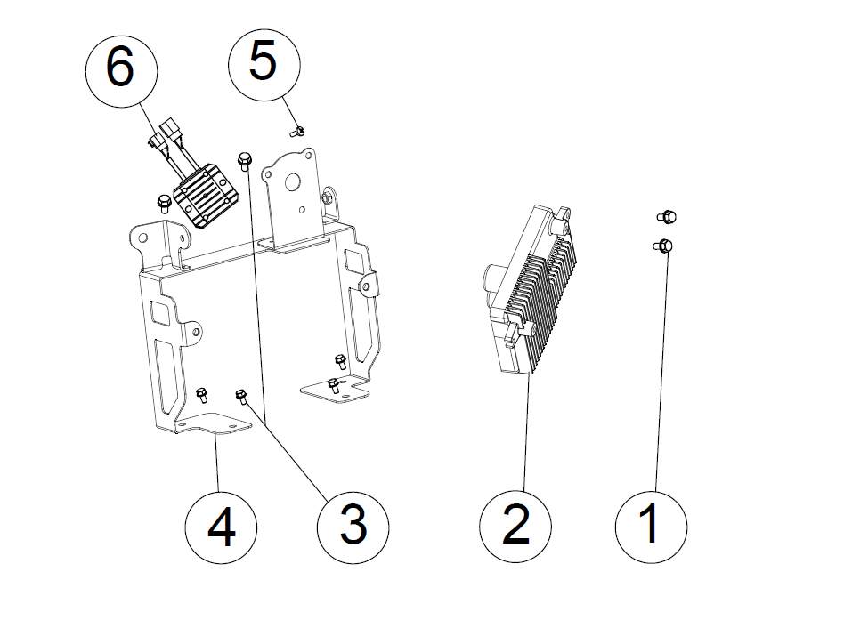
序号  NO. | 零部件编码  Part NO. |  |  | 零部件名称 Description |  |  |  |  |  |  |  |  |  |  |  |  |  |  |  |  |  |  |  |  |  | 数量QTY
序号  NO. |  |  |  | 中文 |  | Part name |  |  |  |  |  |  |  |  |  | Price (USD) |  |  |  |  |  |  |  |  |  |  |  |  | SUA2000i |  | N.W.（kg）/PC
1 | 30101-00588-01 |  |  | 六角法兰面螺栓 |  | Hexagon bolts |  |  |  |  |  |  |  |  |  |  |  |  |  |  |  |  |  |  |  |  |  |  | 2
2 | 20136-00132-00 |  |  | 逆变器部件 |  | Inverter assy |  |  |  |  |  |  |  |  |  |  |  |  |  |  |  |  |  |  |  |  |  |  | 1
3 | 30101-00281-00 |  |  | 六角法兰面螺栓 |  | Hexagon bolts |  |  |  |  |  |  |  |  |  |  |  |  |  |  |  |  |  |  |  |  |  |  | 6
4 | 20014-00397-00 |  |  | 支架部件 |  | Stand components |  |  |  |  |  |  |  |  |  |  |  |  |  |  |  |  |  |  |  |  |  |  | 1
5 | 30111-00064-01 |  |  | 十字槽盘头螺钉 |  | cross recess head screw |  |  |  |  |  |  |  |  |  |  |  |  |  |  |  |  |  |  |  |  |  |  | 1
6 | 31023-00026-00 |  |  | 直流稳压器 |  | DC regulator |  |  |  |  |  |  |  |  |  |  |  |  |  |  |  |  |  |  |  |  |  |  | 1
E-10三合一开关总成/Three in one switch assembly
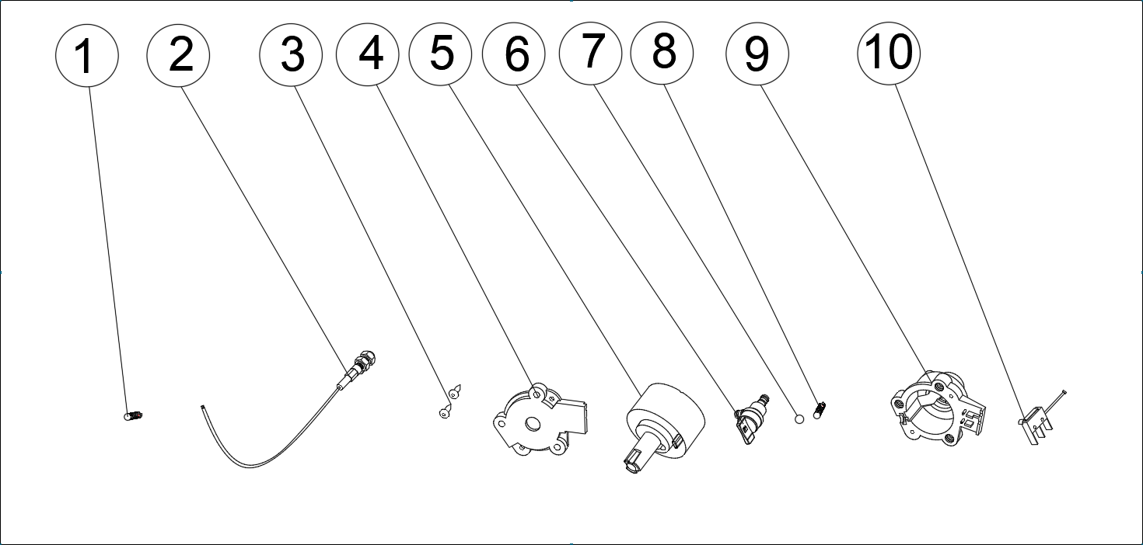

序号  NO. | 零部件编码  Part NO. |  |  | 零部件名称 Description |  |  |  |  |  |  |  |  |  |  |  |  |  |  |  |  | 数量QTY
序号  NO. |  |  |  | 中文 |  | Part Name |  |  |  |  |  |  |  | Price (USD) |  |  |  |  |  |  |  |  |  |  |  |  |  |  | SUA2000i |  | N.W.（kg）/PC
1 | 34015-00049-00 |  |  | 复位弹簧 |  | Back spring |  |  |  |  |  |  |  |  |  |  |  |  |  |  |  |  |  |  |  |  |  |  | 1
2 | 20030-00021-00 |  |  | 风门拉索总成 |  | Choke cable assy |  |  |  |  |  |  |  |  |  |  |  |  |  |  |  |  |  |  |  |  |  |  | 1
3 | 30117-00007-00 |  |  | 十字槽盘头自攻螺钉 |  | cross recessed pan head tapping screws |  |  |  |  |  |  |  |  |  |  |  |  |  |  |  |  |  |  |  |  |  |  | 2
4 | 31026-00090-00 |  |  | 三合一开关固定板 |  | Fixing plate |  |  |  |  |  |  |  |  |  |  |  |  |  |  |  |  |  |  |  |  |  |  | 1
5 | 31026-00088-00 |  |  | 三合一转子 |  | Three-in-one rotor |  |  |  |  |  |  |  |  |  |  |  |  |  |  |  |  |  |  |  |  |  |  | 1
6 | 20113-00018-00 |  |  | 油箱开关 |  | Fuel tank switch |  |  |  |  |  |  |  |  |  |  |  |  |  |  |  |  |  |  |  |  |  |  | 1
7 | 70002-02056-00 |  |  | 钢珠 |  | Ball |  |  |  |  |  |  |  |  |  |  |  |  |  |  |  |  |  |  |  |  |  |  | 1
8 | 34015-00043-00 |  |  | 弹簧 |  | Spring |  |  |  |  |  |  |  |  |  |  |  |  |  |  |  |  |  |  |  |  |  |  | 1
9 | 31026-00089-00 |  |  | 三合一开关座 |  | Three in one switch seat |  |  |  |  |  |  |  |  |  |  |  |  |  |  |  |  |  |  |  |  |  |  | 1
10 | 31026-00060-00 |  |  | 熄火开关组件 |  | flameout switch |  |  |  |  |  |  |  |  |  |  |  |  |  |  |  |  |  |  |  |  |  |  | 1

